String:
String Pool: String Pool is the space reserved in the heap memory to store the strings. If we create a string JVM will check in the string pool and if the string is not there it will be created or if already exists the referenced to the new string literal.
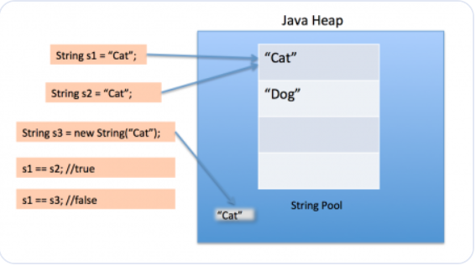
String Literal: String literal makes java memory efficient because no new objects are created if it exists already in the string constant pool
Immutable: String in java is immutable or unchangeable or unmodifiable. If a string object is created it cannot be modified, and if you need to modify, we can create a new object or reference to a object already created and store.
String was made immutable because if there are multiple reference pointing to the one object and any reference variable changes the value of the object every reference variable will be affected so that string is made immutable in java.
Features: Class loader uses string object as arguments so if the string is mutable, won’t load the correct class. Reduce Heap memory, Security and synchronization issue are reduced.
Ways to create the string:
String Literal
String s1="Welcome"; and String s2="Welcome"; will have the same reference.
New Keyword
String s = new String(“Welcome”); New object s is created in (non-pool) heap memory and string literal is placed in string pool. One object in string constant pool and other in non-pool(heap).
== and .equals()method:
== - check whether the references and content of the two string objects are equal or not
.equals() - check whether only the content of the two string objects are equal or not
Intern() method:
The method intern() creates an exact copy of a String object in the heap memory and stores it in the String constant pool.
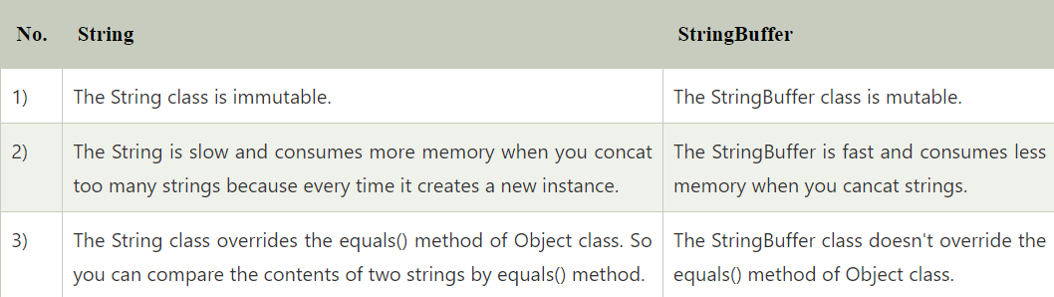
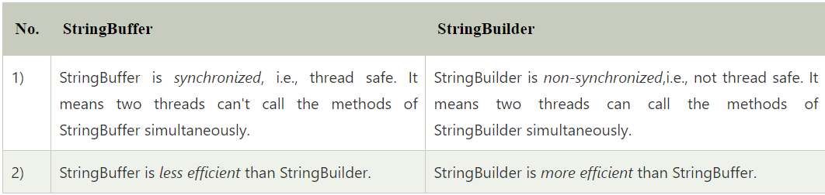
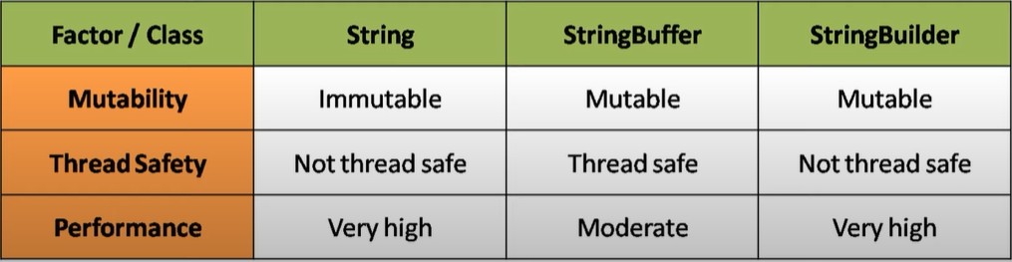
Immutable Class in java –
Make the class as final, Make variables as private and final, should not have setter methods, initialize variable in constructor and return clone in getter method.
Tostring() method:
The toString() method returns the string representation of an object
Chararray() preferred over string to save passwords: String stays in string pool until it is garbage collected and stays in the memory so it can be retrieved from memory dump. CharArray allows us to set it to blank whenever we are done with the password so its used for password.
Intern(): The intern() method in Java is used to ensure that all identical string literals are stored only once in the String pool (a part of the Java heap) and returns a canonical representation (a single, shared string object) for a given string
- When you call intern() on a string object, the JVM checks if a string with the same value already exists in the String pool.
- If a string with the same value exists, intern() returns a reference to that existing string object.
- If no string with the same value exists, intern() creates a new string object in the String pool, and returns a reference to it.

